RSOC 27: Faith and Resilience in Silicon Valley
Winter 2017
T-TH 3:50-5:30 pm

Professor: Socorro Castañeda, Liles, Ph.D.
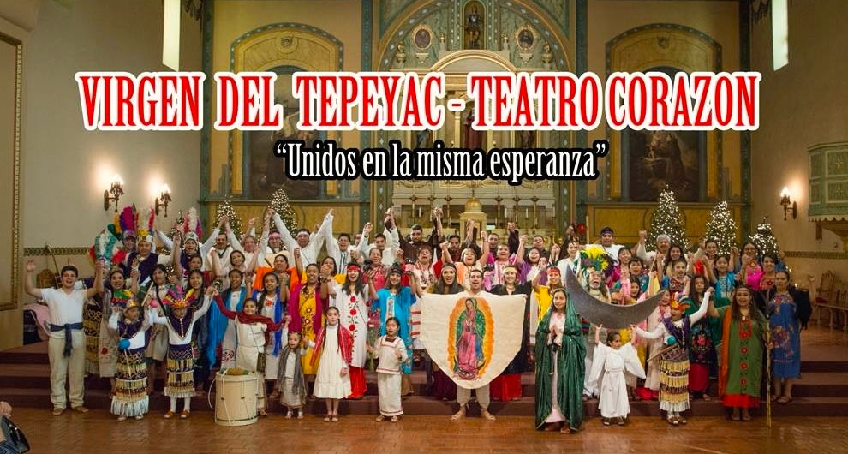
Email: mscastanedaliles@scu.edu
Office: Kenna Hall 300E
Phone: (408) 551-3181
Email: mscastanedaliles@scu.edu
Office Hours: Wednesdays 3:00-5:00 pm
Class: Kenna 214

This course fulfills Santa Clara University’s Core Requirement for RTC 2 and require weekly engagement through the Community Base Learning (CBL) program.
[NOTE] This course does not fulfill the ELSJ requirement.

Required Text: Enrique’s Journey by Sonia Nazario (available at our bookstore)
Other Readings: The rest of the readings are available on Camino. Check the “Files” tab.

Course Description:
With a focus on the Sacred Heart Parish/Greater Washington community in San Jose, this course analyzes the intersection of race, class, gender, faith, and resilience in Silicon Valley. Students explore the complex and diverse socio-religious dimensions of human existence through an applied sociological analysis. This class centers on Catholic social teachings, which emphasize the belief that we are made in God's image, and are called to build relationships of love and justice with others. From within this context we investigate the dialectical relationship between faith and resilience in a community that has been highly gentrified as Silicon Valley continues to expand.

COURSE GOALS:
The first goal of this course is to gain a better understanding of Silicon Valley and the ways faith and resilience materialize into social change among members of this community. With our university’s vision to “educate citizens and leaders of competence, conscience, and compassion,” the second goal of this class is to engage students in a reflection of the ways they could apply their chosen majors in light of their greatest gifts and society’s utmost needs. With these two goals in mind, the learning environment of this class expands beyond our Santa Clara University campus. This is done in two ways:

- Through the Community-based Learning (CBL) program in conjunction with The Thriving Neighbors Initiative, students will work with community members and non-profit organizations in the Sacred Heart Parish/Greater Washington neighborhood.

CBL: Students are required to sign up for a community placement on the first week of class. You will not get credit for the course if you do not sign up for a CBL. You are required to attend an orientation and spend 2 hours per week thereafter (Orientation Week 2 and CBL placement participation Weeks 3-10). The sites in the Sacred Heart Parish/Greater Washington community are:

- Alma Senior Center
- Bronco Urban Gardens (Gardner, Washington)
- CET Immigration
- CET Sobrato
- Children, Youth & Family (CORAL at Washington)
- Community United
- Estrella Family Service
- Sacred Heart Education Center
- Sacred Heart Community Service,
- Santa Maria Urban Ministry
Washington Elementary

- This course will have an off-campus visit on the second week of the quarter. Our main texts for the course will the life-experiences of the people living and working in the Sacred Heart Parish/Greater Washington neighborhood. This will take place through your weekly participation in a local organization through the CBL program. We will also have guest lectures by community members who will be teaching on the topics addressed in the class from their own social context in the community.

The teaching model that we use in this class builds on Brazilian educator and philosopher Paulo Freire’s notion that learning takes place in multiple ways that go beyond the more traditional professor-student setting. The purpose is to provide students with a stimulating and engaging learning environment through various teaching methods that include: readings, lectures, small group and class discussions, group and student presentations, community-based learning, and guest lectures.

RTC2 Learning Objectives
- “Analyze complex and diverse religious phenomena” in the context of social structures, including race/ethnicity, class, gender, and sexuality;

- “Integrate and compare several different disciplinary methods to a coherent set of religious phenomena;”

- “Clarify and express beliefs in light of [your] critical inquiry into the socio-religious dimensions of human existence.”

Grading Scale:
- 94 and above = A
- 90-93 = A-
- 87-89 = B+
- 84-86 = B
- 80-83 = B-
- 77-79 = C+
- 74-76 = C
- 70-73 = C-
- 67-69 = D+
- 64-66 = D
- 61-63 = D-
- 60 and below = F

Feedback: Students will receive feedback from the professor through comments on papers. You are also encouraged to attend office hours if you have any further questions.

POLICIES:
- You are expected to attend every class session; participate in classroom and small group discussions.

- Assignments that are handed in late will be penalized one-third grade per day (i.e. from an A to an A-, an A- to a B+, a B+ to a B, etc).

- You must do well in all assignments to pass the course. The dates and material in this syllabus may be subject to change, so listen carefully to announcements in class.
- I do not accept e-mailed submissions of written work. You need to use Camino.
- Santa Clara University strongly believes in academic integrity and honesty; therefore, cheating, plagiarism, or other forms of academic dishonesty will not be tolerated in this course and the student may receive a failing grade. Please visit the following website for further information on Santa Clara University’s policy regarding academic integrity:
http://www.scu.edu/academics/bulletins/undergraduate/Academic-Integrity.cfm

- No cell phones. If you are caught texting I will mark you absent for that day.
- No Talking in class. If you are caught talking in class you will forfeit your attendance grade for the day.
- No laptops, electronic notebooks or i-pads allowed in class.
- You are allowed to bring a drink and a snack as long as it does not disrupt classroom lectures and your participation in class discussions.
- Students requiring accommodations for disabilities please let the professor know on the first week of class. To request academic accommodations for a disability, students must be registered with Disabilities Resources, located in Benson 216. If you would like to register with Disabilities Resources, please visit their office in Benson 216 or call at 408-554-4109. You will need to register and provide documentation of a disability prior to receiving academic accommodations. For further instructions about the process to receive accommodations visit: http://www.scu.edu/advising/learning/disabilities/

Paper Expectations: An A Paper is of high quality; that is, the student engages in a critical analysis by demonstrating knowledge of the concepts and topics covered in class. It introduces the reader to the topic before the in-depth analysis. Every paper should have a thesis statement. It integrates class readings and lectures in a clear, comprehensive, and creative way. The paper addresses all the points. It is spell-checked and all works are cited properly. It also has a separate page with the bibliography of the works cited. Final paper should be uploaded via Camino.

NOTE: Wikipedia, websites, magazines (i.e., Times Magazine, News Week, and the National Geographic), and newspapers are not considered scholarly sources and will not be counted as such. You may choose to use the above material ONLY as additional supportive evidence. By scholarly sources I refer to academic journal articles and books. Email me if you are not sure you are using the right sources.
You will lose points if I see the following:
- No thesis statement
- Some of the statements are too general.
- Arguments are not complex and/or the student spends more time analyzing one aspect over the other.
- Outside sources are not fully integrated.
- The paper consists of mainly quotes from scholars and the student’s voice is lost.
- Student relies on Internet sources and not on academic material.
- Sentences are circular and vague.
- Incomplete sentences.
- The analysis seems rushed and circular.
- Some arguments need further development.
- Personal opinions are not supported by academic evidence.
- The sources listed in the bibliography do not appear in the main text.
- Incomplete citations.
- The paper has no name.
- Student waits until the end of the paper to integrate readings. This is not acceptable. Remember you must weave your readings/academic sources throughout the paper.
- Questions on the assignments are not “food for thought.” I expect you to answer every question.

Email Etiquette
- I have come across many emails from students that begin with:
  - “Hey Prof.”
  - “Hey Professor” or “Mrs./Ms./Mr.”
  - Or the message is not addressed at all.

As a general rule, if you email your professors the message should start with: “Dear Professor [Name of Professor],” and make sure you spell the professor’s name correctly.

STUDENT LEARNING ASSESSMENT & GRADING AT A GLANCE
Attendance and Participation 10 points
3 journal entries (each 5 points) 15 points
Short Exam 1 15 Points
Short Exam 2 15 Points
Short Exam 3 15 Points
Ethnographic Paper 30 points
TOTAL POINTS 100 Points

Attendance and class participation: I will take roll at random times during the quarter. Participation in class is an important component of the learning process. Therefore, you will be evaluated on the extent to which you participate in class. As part of the participation grade on certain days I may ask students to write in class:
- The author’s argument/s and key concepts in the reading of the day.
- What you found most insightful and why
- One question that came about after reading the article/chapter essay.
***If you are absent you cannot make up this portion of the grade since it is part of the attendance and class participation.

Students must come to class ready to participate in discussion everyday. Students who consistently do not participate or play on their electronic devices will lose ½ point from their “Attendance & Participation” grade each time. Students may be eligible for excused absences (no more than 2) should an emergency arise, but you must give the professor 24-hour notice.
Persistent absences, tardiness and early departure from class will affect your participation grade.

Students will be assessed on their active participation in the small groups and class discussions, and on their ability to bridge what they learn in class and at their placements. Students are required to spend 16 contact hours at the community-based learning placement site over the quarter. Students are also expected to integrate and engage with the people at their placement and keep a weekly journal. (RTC2 Learning Objective 3)

Note to Students: Based on their rich life experiences, the people at your placement have much to teach you, so take maximum advantage of this valuable learning opportunity. On the first day of class we will go over the various community-based learning sites that complement the course objectives.

Three Exams each worth 15 points: Your short exams will be based on the readings and class & guest lectures. Professor will provide the specifics of each Exam in class.

Three journal entries: The community where you will do your community engagement has a rich tradition of Latinx popular Catholic practices that mirror the challenges and resilience of this community. It also has strong ties to Santa Clara University that go back at least two decades. In the next weeks you will have plenty of opportunities to learn about this community from first-hand accounts of community members.

You will write a total of three entries, each worth 5 points. The professor will provide the question/s to be addressed ahead of time. On selected days you will be submitting via Camino a 725-word journal entry, double-spaced, and size 12 font in times new roman. We will also have class time to reflect on the entries in small group and class discussions. This assignment will help you gain a greater understanding of the community’s reality. (RTC2 Learning Object 1 and 3)

Ethnographic Observation Paper Extra Credit (3 points): For this assignment you are to write a 725-word report based on your observations in the community (double-spaced and 12 size font in times new roman). The paper is to be submitted via Camino on Tuesday January 24th by 11:59 pm. The professor will provide instructions and guidelines for the paper. I will not accept late papers. If you do not turn it in by the due date you lose your chance of earning 3 extra credit points.
Final Research Paper: To today’s entrepreneur, investor and computer wizards, Silicon Valley is an innovative place. Companies like Apple, Cisco Systems, and Adobe System, among others, place Silicon Valley among one of the most important corporate hubs in America. These companies have attracted many young college graduates from across the nation and indeed the world. The need for more housing resulted in the gentrification of San Jose’s downtown area. Low-income, neglected neighborhoods suddenly underwent urban revitalization. This capitalist revolution came at a high price to working-class residents in the downtown San Jose area like the Sacred Heart Parish/Greater Washington neighborhood. Entire communities were uprooted and torn apart by freeways and luxury condos and town homes that residents who had previously lived there could no longer afford.
Drawing on the Catholic social teachings we have discussed in class, journal entries, oral interview, census data, your final assignment is a comprehensive analysis on one aspect of this community. (RTC2, Learning Objectives 1, 2, and 3) (Course Goals) The professor will provide the specifics for this assignment in class.

RSOC27 Winter 2017—Weekly Schedule

Week 1
Catholic Social Teachings and the Preferential Option for the Poor
January 10 Intro to Course

January 12
READING: Social Justice and the Mission of the Church in Living Justice: Catholic Social Teaching in Action by Thomas Massaro (Camino)
Week 2
From Valley of the Hearts Delight to Silicon Valley
January 17 The other Silicon Valley
Class meets at Sacred Heart Community/Greater Washington neighborhood
READING: Enrique’s Journey Chapters 1 and 2

January 19 The other Silicon Valley
Class meets at Sacred Heart Community/Greater Washington neighborhood
READING: Enrique’s Journey Chapters 3 and 4

Week 3
Community and the common good in Silicon Valley
January 24
Case Study: Silicon Valley within the context of the common good and Catholic social teachings..
READING TBA
READING: Enrique’s Journey Chapter 5
**Extra Credit Ethnographic Observations Paper due**

January 26
Case Study: Underserved communities and the common good
READING: Voices of Change by Hispanic Foundation of Silicon Valley
Access URL: https://issuu.com/hfsv/docs/nfreportsp/3?e=12231596/8392419

Week 4
Human Dignity
January 31 Short Exam 1 + Lecture

February 2 Lecture on Immigration
READING: Enrique’s Journey Chapter 6

Week 5
Faith, Resilience, and Restorative Justice
February 7
READING: TBA
READING: Enrique’s Journey Chapters 7
Lecture on faith and resilience

February 9
Case Study: Faith and Restorative Justice—Sister Mariann Cantlon, CSJ, Associate Director for the Department of Restorative Justice in the Office of Social Ministries for the Diocese of San Jose
READING: TBA

Week 6
Option for the poor and vulnerable—Education and the Jesuit response
February 14
Case Study—Education and the Jesuit response—Sonya Arriola, President of Sacred Heart Nativity Schools
READING: “The Nativity School Model” in Improving urban middle schools: lessons from the Nativity schools by L. Mickey Fenzel

February 16 Short Exam 2 + Lecture

Week 7
Testimonios—Oral Histories as the human face of God
February 21
READING: Oral Histories and Communities of Color (Camino)
READING: Enrique’s Journey Chapter 8
Lecture on oral histories and the human face of God

February 23
Lecture continued and Case Study: Human face of God—The mothers of Washington Elementary

Week 8—Global Solidarity
From compassion to collaboration moving forward by embodying our Jesuit tradition

February 28
Case Study: Thriving Neighbors Initiative—Jennifer Merritt, Director of Community-based Learning and Irene Cermeño, Program Director at Thriving Neighbors Initiative, Ignatian Center for Jesuit Education
READING: “Greater Washington: Voces de la Comunidad (Voices of the Community)
READING: Enrique’s Journey Epilogue

March 2 Short Exam 3 + Lecture

Week 9
The Reality of Unaccompanied Children
March 7
Lecture on unaccompanied children
READING: TBA
READING: Enrique’s Journey Afterward: Immigration Nation

March 9 Lecture continued and Case Study: Under the Same Moon

Week 10
Our chosen majors in light of society’s utmost needs:
What are we being call to do?
March 14 Case Study continued

March 16 Class Reflection on what our Jesuit tradition calls us to do.

The RTC Learning Objectives are taken from “What to do to get your course approved for RTC2” information sheet, page 1. Website address: Website: http://www.scu.edu/provost/ugst/core2009/Learning-Objectives.cfm.
Popular Catholic practices are people’s attempt to contextualize their faith in the collective life experience of a community.
See also Flores and Benmayor, 1997.

